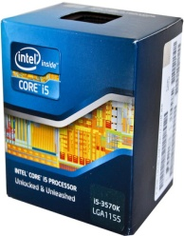 | Intel 3.4 GHz LGA1155 Core i5 3570K Processor | - 64-bit Architecture  - DDR3-1600  - 4 Cores  - 77 W Maximum Thermal Design Power (TDP)  - 22 nm Manufacturing Process  - Integrated Graphics  - 32 GB DDR3-1333  - Desktop Processor | Rs. 16900 | 0 | Rs. 16900
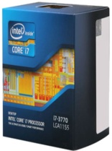 | Intel 3.4 GHz LGA1155 Core i7 3770 Processor | - 32 GB DDR3-1333  - Desktop Processor  - Integrated Graphics  - DDR3-1600  - 77 W Maximum Thermal Design Power (TDP)  - 64-bit Architecture  - 4 Cores  - 22 nm Manufacturing Process | Rs. 20988 | 0 | Rs. 20988
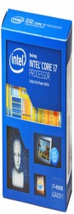 | Intel 3.4 GHz LGA 2011 i7 4930K 4th Generation Processor | LGA 2011 Socket Type  Core i7-4000 Desktop  i7 4930K 4th Generation  6 Cores  3.4 GHz Clock Speed | Rs. 62500 | 25 | Rs. 46500
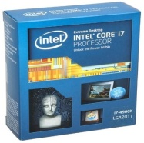 | Intel 3.6 GHz LGA 2011 i7 4960X 4th Generation Processor | LGA 2011 Socket Type  Core i7-4000 Desktop  i7 4960X 4th Generation  6 Cores  3.6 GHz Clock Speed | Rs. 89000 | 20 | Rs. 70900
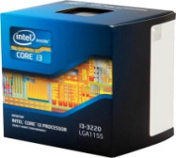 | Intel i3 3220 | - 64-bit Architechture  - 2 Cores  - Desktop Processor  - 3.3 GHz Clock Speed  - FCLGA1155 Socket Type  - 55 W Maximum Thermal Design Power (TDP)  - 22 nm Manufacturing Process | Rs. 7950 | 0 | Rs. 7950
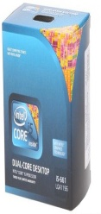 | Intel 3.33 GHz LGA1156 Core i5-661 Processor | - 32 nm Manufacturing Process  - Desktop Processor  - 87 W Maximum Thermal Design Power (TDP)  - 2 Cores  - 64-bit Architecture  - 3.33 GHz Clock Speed with Maximum Turbo Speed of 3.6 GHz  - LGA1156 Socket Type | Rs. 12301 | 0 | Rs. 12301
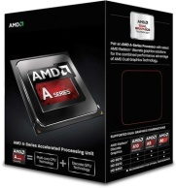 | AMD 3.9 GHz FM2 Quad-Core A8-6600K APU for Desktops with Radeon HD 8570D Processor | FM2 Socket Type  A8-Series  Quad-Core A8-6600K APU for Desktops with Radeon HD 8570D  4 Cores  3.9 GHz Clock Speed | Rs. 8056 | 0 | Rs. 8056
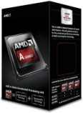 | AMD 4.1 GHz FM2 A10-Series A10-6800K Four Core Processor | FM2 Socket Type  A10-Series  A10-Series A10-6800K Four Core  4 Cores  4.1 GHz Clock Speed | Rs. 9761 | 0 | Rs. 9761
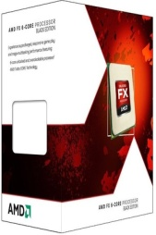 | AMD 3.5 AM3+ FX 6-Core Edition FX-6300 (FD6300WMHKBOX) Processor | AM3+ Socket Type  FX 6-Core  FX 6-Core Edition FX-6300 (FD6300WMHKBOX)  6 Cores  3.5 with Maximum Turbo Speed of4.1 Clock Speed | Rs. 8223 | 0 | Rs. 8223
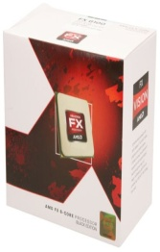 | AMD 3.3 GHz AM3 FX6100 Processor | - 3.3 GHz Clock Speed  - 6 Cores  - 32 nm Manufacturing Process  - 8192 KB (L3)  - 6144 KB (L2)  - AM3 Socket Type  - 95 W Maximum Thermal Design Power (TDP) | Rs. 7420 | 0 | Rs. 7420
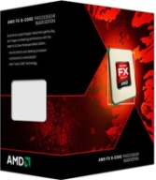 | AMD FX 8350 | - AM3 Socket Type  - 8 MB (L2)  - 64-bit Architechture  - 32 nm Manufacturing Process  - 8 Cores  - 4 GHz Clock Speed  - Desktop Processors | Rs. 13000 | 0 | Rs. 13000
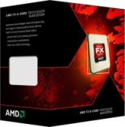 | AMD 3.5 GHz AM3 FX 8320 8 Core Piledriver Processor | - 8 Cores  - 3.5 GHz Clock Speed  - AM3 Socket Type  - 64-bit Architechture  - 32 nm Manufacturing Process  - Desktop Processors  - 8 MB (L2) | Rs. 10395 | 0 | Rs. 10395

